**IDEATION PHASE**

**BRAINSTORM & IDEA PRIORITIZATION**

|  |  |
| --- | --- |
| **Date** | 5 October 2022 |
| **Team ID** | PNT2022TMID47589 |
| **Project Name** | Personal Assistance for seniors who are self-reliant |
| **Maximum Marks** | 4 Marks |

**DEFINE PROBLEM STATEMENT:**

Senior citizen or Elders may often fail to consume their medication whether it was from forgetting to take the medicine, from taking medicine at the wrong time or even from taking too much medicine. Therefore, the family members or caretaker has to remind them to take the pills on time. So, we have focus on those elders who having difficulty to take medication on time independently. You may also keep track them.

**BRAINSTORM:**

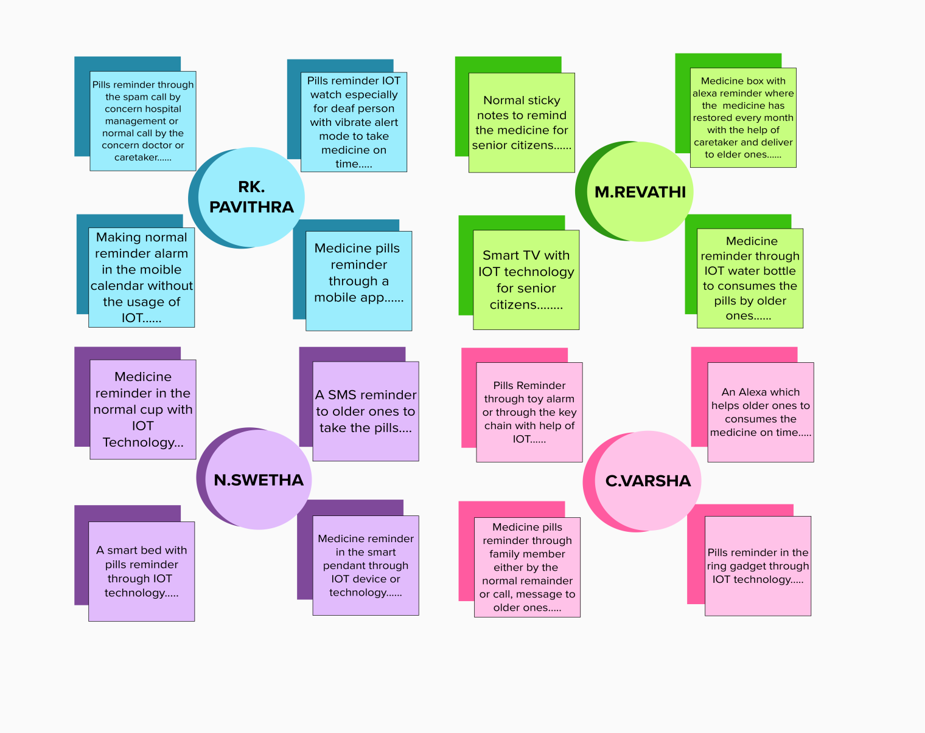

**Reference Link:**

https://app.mural.co/invitation/mural/narayanan8752/1664702530967?sender=ufe3c1e1f6040a2d8c0685732&key=44a7028b-b5b2-4d0d-a3d2-4de7ac128538

**GROUP IDEAS:**

* The Smart IoT Gadgets should accompany the elder ones to remind their pills or vaccine on the time independently.
* All IoT device should monitor the elder whether they have consume medicine or not and make record.
* All IoT device should monitor Medicine name, Strength, dose and everything & these things should be displayed.
* This IoT application should alert to refill the medicine.

**PRIORITIZE:**

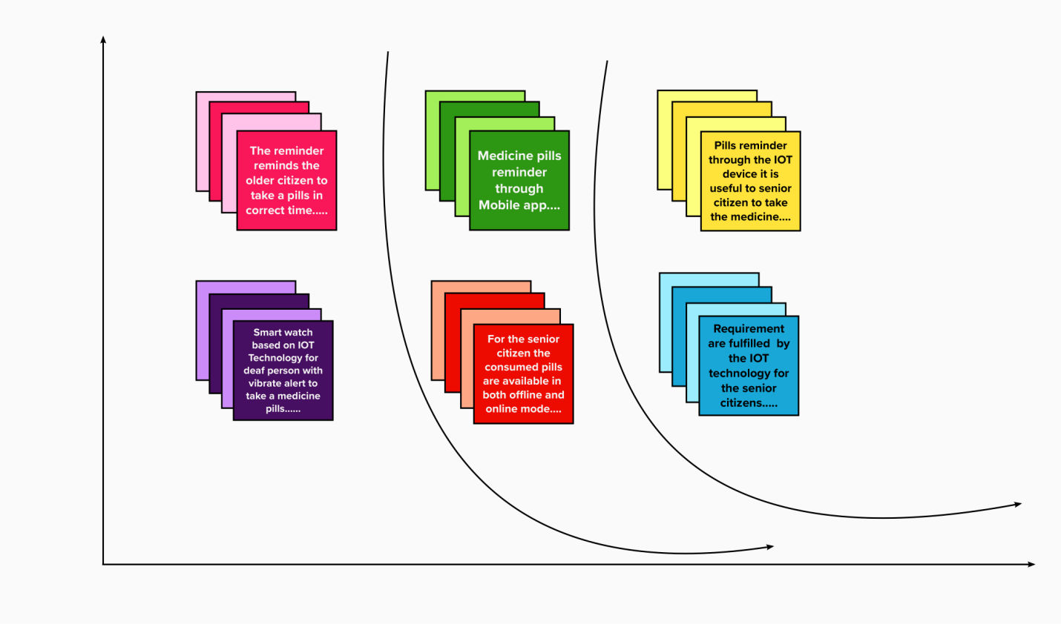

Reference Link: https://app.mural.co/invitation/mural/narayanan8752/1664775138224?sender=ufe3c1e1f6040a2d8c0685732&key=fe3a6d4c-5e51-439c-a6e2-cd8195f04e01